**Read the text:**

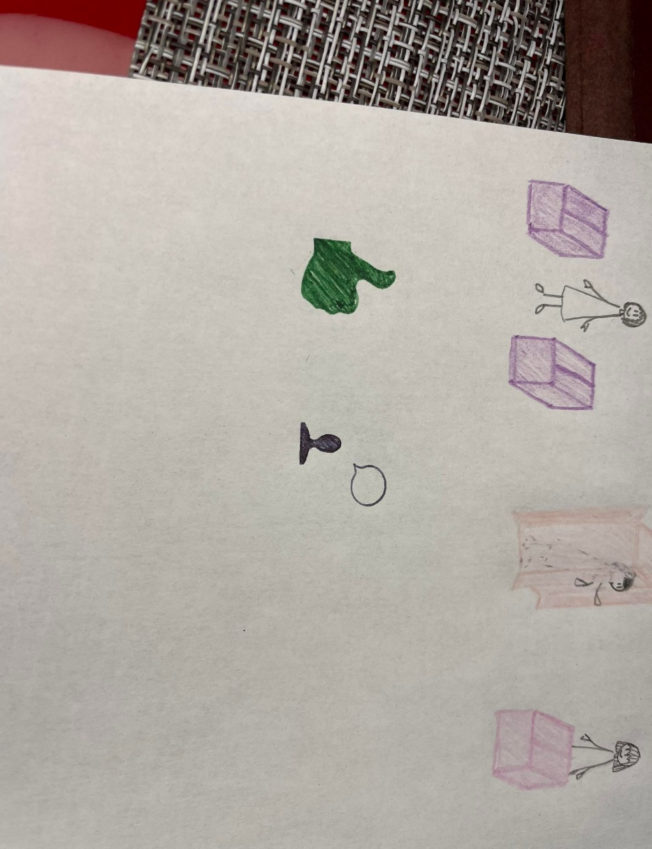Last weekend was really nice. On Saturday, I went to the cinema with my friends. We watched a comedy movie and it was very funny. After that, we went to a cafe and had some juice and cake. It was great to see my friends and chat about our lives.

On Sunday, I spent time with my family. We visited my grandparents who live in the countryside. They cooked us a delicious lunch with lots of food. We ate roast chicken, potatoes, vegetables, and salad. Everything was so tasty!

In the afternoon, we went for a walk in the fields near my grandparents' house. The weather was sunny and warm, and it was lovely to be outside in nature. We saw some cows and sheep.

My weekends are always different. And usually I spend them with my family or friends.

**True or false?**  
1. The writer went to the cinema with his/her family. __  
2. The writer watched a horror movie. __  
3. The writer went to a cafe after the cinema. __   
4. The writer had coffee and cake at the cafe. __  
5. The writer spent Sunday with his/her family. __  
6. The writer's grandparents live in the city. __  
7. The writer's family had a delicious lunch. __  
8. They ate pizza for lunch. __  
9. The writer's family went to the beach. __   
10. The weather was sunny and warm on Sunday. __