**Make a simple bird feeder**

**You will need:**

[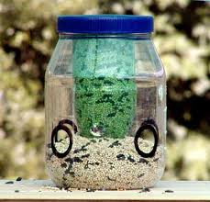](http://www.google.co.uk/imgres?imgurl=http://www.runnerduck.com/images/bird_feeder_2.jpg&imgrefurl=http://www.runnerduck.com/plastic_bird_feeder.htm&usg=__iCAaNVJY-I8ZxfNzA07ptmOfKuo=&h=400&w=417&sz=28&hl=en&start=7&zoom=1&itbs=1&tbnid=1PXyJETeDHhvdM:&tbnh=120&tbnw=125&prev=/images?q%3Dbird%2Bfeeder%2Bplastic%2Bbottle%26hl%3Den%26sa%3DG%26gbv%3D2%26tbs%3Disch:1)

1. Clean plastic bottle, yoghurt pot or milk carton

2. Wire or string

3. Bird seed

4. Scissors

**What to do:**

1. Cut a round hole about half way up the side of the bottle. The hole should be big enough to allow a bird access.
2. Make a few small holes in the bottom of your feeder to allow any

[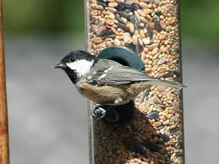](http://www.google.co.uk/imgres?imgurl=http://images.quickblogcast.com/4/3/6/4/3/143794-134634/gardenbirdfeeder1.jpg?a%3D74&imgrefurl=http://wildnewjersey.tv/2009/12/12/nj-audubon-bird-watching-at-the-birdfeeders.aspx&usg=__-lB_YFUfiWZR_biTKu3kOQxHW28=&h=612&w=816&sz=58&hl=en&start=51&zoom=1&itbs=1&tbnid=2nzOh1qT3RmScM:&tbnh=108&tbnw=144&prev=/images?q%3Dbird%2Bfeeding%26start%3D36%26hl%3Den%26sa%3DN%26gbv%3D2%26ndsp%3D18%26tbs%3Disch:1)rain water to drain away.

3. Fill it to the hole with bird seed.

4. Hang it with wire or strong string from a tree or your washing line.

[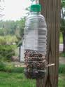](http://www.google.co.uk/imgres?imgurl=http://i.acdn.us/image/A1066/1066114/300_1066114.jpg&imgrefurl=http://www.associatedcontent.com/article/2910564/recycled_crafts_plastic_bottle_bird.html&usg=__XyRh9EFFqckPw33MMrB_KfHxKL0=&h=400&w=300&sz=80&hl=en&start=31&zoom=1&itbs=1&tbnid=iTeY9ySJKRUdXM:&tbnh=124&tbnw=93&prev=/images?q%3Dbird%2Bfeeder%2Bplastic%2Bbottle%26start%3D18%26hl%3Den%26sa%3DN%26gbv%3D2%26ndsp%3D18%26tbs%3Disch:1)Now birds should soon start flocking to your garden to feed on your lovely seeds,

Make sure your bird feeder is in good condition all the time, top it up with seeds if it’s running low; if the bottle cracks or the food gets mouldy, make a new feeder.

[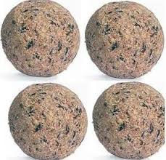](http://www.google.co.uk/imgres?imgurl=http://www.food4wildbirds.co.uk/images/large%20fat%20ball.jpg&imgrefurl=http://www.food4wildbirds.co.uk/large-fat-balls-pack-24-p-1479.html&usg=__DWoPb1gN8Hu08iU1ZZt22iJmKYQ=&h=274&w=286&sz=25&hl=en&start=2&zoom=1&itbs=1&tbnid=neDFWaJg3WUmvM:&tbnh=110&tbnw=115&prev=/images?q%3Dfat%2Bball%26hl%3Den%26sa%3DG%26gbv%3D2%26tbs%3Disch:1)

**Fat Ball Feeders Recipe:**

* First collect some old yoghurt tubs.
* Tie a longish piece of string to a lolly stick.
* Wedge the stick in the bottom of the yoghurt pot with the tail of the string coming up out of it.
* When you pour the fat mix into the pot, make sure the stick stays at the bottom and the string is trailing out of the top.
* When set, you can turn it out like a lolly and hang it up from the string.
* You will need some fat for binding the mixture. Lard is very cheap and a big block will go a long way.
* Melt the lard in a saucepan until it is liquid - but not too hot (as you will end up with a pan of smoking oil ).
* Cool a little and add some mixed wild bird seed, raisins, unsalted peanuts, and any small pieces of leftover cake or bread (not too many of these).
* Then pour the mix into the old yoghurt pots.

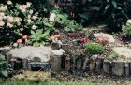

**Hedgehog house**

**IN THE WILD**

[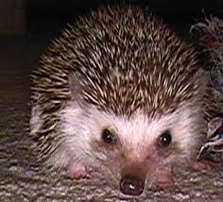](http://www.google.co.uk/imgres?imgurl=http://www.wildlifesafari.info/images/hedgehog.jpg&imgrefurl=http://www.wildlifesafari.info/hedgehog.html&usg=__d4IV5bwye4Da8P4RUvxc9eM3TLM=&h=338&w=372&sz=22&hl=en&start=11&zoom=1&itbs=1&tbnid=WknXan5x6F4aDM:&tbnh=111&tbnw=122&prev=/images?q%3Dhedgehog%26hl%3Den%26sa%3DG%26gbv%3D2%26tbs%3Disch:1)Efficient winter nests are essential if hedgehogs are to survive hibernation. Thus, in autumn, they begin to collect leaves, grass, straw, bracken, reeds etc. and use these materials for building their own nests under hedgerows, fallen logs or piles of brushwood. These "HIBERNACULA" prove to be surprisingly waterproof and good insulation against the cold.

**IN THE NATURAL GARDEN**

Most gardens have a supply of the materials mentioned above and suitable sites for nests - under sheds, compost heaps, shrubs and piles of leaves or behind stacks of logs and under spare building materials. In these circumstances, if hedgehogs want to spend a winter here, they should be able to get on and build their own shelters. However, you may wish to provide your 'resident' hedgehog with (or encourage any in the vicinity to become 'resident' in your garden by the provision of) a more permanent structure.

**Homemade house**

1. Get a big, thick cardboard box and cut two side air vents about 15cm by 5cm and an entrance about 15cm in diameter.
2. Put some shredded newspapers inside with clean, dry grass or straw on top and tuck the box near a hedge, if possible with the entrance facing South.
3. The top of the box should then be covered with a small piece of plastic sheeting, for example, an "opened up" old carrier bag.
4. Twigs put all round to make a dome and then covered with dry grass and leaves.