**Growing potatoes**

[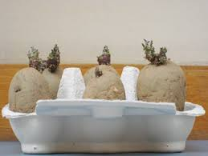](http://www.google.co.uk/imgres?imgurl=http://www.eu-sol.net/images/copy5_of_images/Chitting-potatoes3.jpg&imgrefurl=http://www.eu-sol.net/public/try-this/potato-cam&usg=__elsM-_A_AtP_4p6r2aYbZCt1Fw0=&h=293&w=390&sz=26&hl=en&start=2&zoom=1&itbs=1&tbnid=6_55D4IJaC151M:&tbnh=92&tbnw=123&prev=/images%3Fq%3Dchitting%2Bpotato%26hl%3Den%26sa%3DG%26gbv%3D2%26tbs%3Disch:1)You can buy potatoes to grow from garden centres or you could use old potatoes that have started to sprout.

### 

### **How to chit**

* Chitting simply means encouraging the seed potatoes to sprout before planting.
* Start chitting from late January early February, about six weeks before you intend to plant out the potatoes.
* Put the potatoes in trays or old egg boxes, with plenty of natural light.
* The potatoes are ready to be planted out when the shoots are 1.5-2.5cm (0.5-1in) long

### **How to plant**

* A hessian bag for life makes an excellent potato planter
* Plant your chitted potatoes when the soil has started to warm up, usually from mid-March or early April.
* Place a layer of newspaper or part of a feed sack into the bag to cover the drainage holes. This will hold in moisture in the beginning and invite the earthworms that are a vital part of the composting process that will be going on inside the planter to feed your potatoes.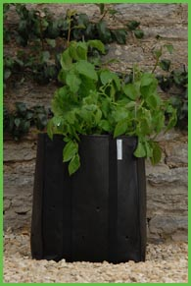
* Add your compost or soil to around 30 cm from the top.
* Place 4 to 6 potatoes on top of the compost.
* Cover the potatoes with more compost leaving about a 15 cm space at the top of the potato planter.
* As soon as the shoots appear, put more compost over the plant l so that the shoots are just buried.
* You need to do this at regular intervals and by the end of the season each plant will have a small mound around it about 15cm (6in) high.

### **Harvesting**

* Your home-grown potatoes should be ready for lifting from June until September. Earlies can be lifted and eaten as soon as they're ready. This will be when above-ground growth is still green, and usually as soon as the flowers open.

[](http://www.google.co.uk/imgres?imgurl=http://www.rhs.org.uk/Media/Images/Practical/WateringPotatoes_LW%3Fwidth%3D432&imgrefurl=http://www.rhs.org.uk/Gardening/Grow-Your-Own/jobs-to-do/July&usg=__qrHduF3By3hhVlBYs-RoCfX6epA=&h=243&w=432&sz=32&hl=en&start=2&zoom=1&um=1&itbs=1&tbnid=6vONLhpq4cKddM:&tbnh=71&tbnw=126&prev=/images%3Fq%3Dwatering%2Bpotatoes%26um%3D1%26hl%3Den%26sa%3DN%26rls%3Dcom.microsoft:en-gb:IE-Address%26rlz%3D1I7ACAW%26biw%3D1345%26bih%3D612%26ndsp%3D18%26tbs%3Disch:1)**Remember**

Potatoes like plenty of water and sun